lnx x的自然对数
lgx
logx
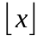 max{n n x, integer n}
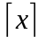 min{n n x, integer n}
x mod y 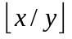
{x} x mod 1
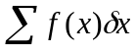 indefinite summation
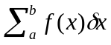 definite summation
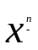 falling factorial power: x!/(x-n)!
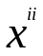 rising factorial power: (x + n)/(x)
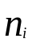 subfactorial: n!/0! – n!/1! + … + 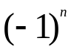n!/n!
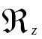 real part: x, if z = x + iy
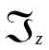 imaginary part: y, if z = x + iy
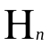 harmonic number(调和数): 1/1 + … + 1/n
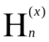 generized harmonic number: 1/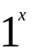 + … + 1/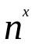
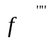(z) mth derivative of f at z
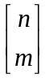 Stirling cycle number
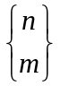 Stirling subset number
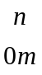 Eulerian number
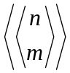 Second-order Eulerian number
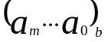 radix notation for 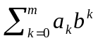
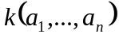 continuant polynomial
F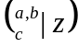 hypergeometric function
#A cardinality: number of elements in the set A
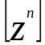f(z) coefficient of 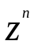 in f(z)
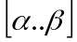 closed interval: the set {x 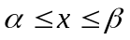}
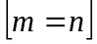 1 if m = n,otherwise 0*
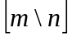 1 if m divides n, otherwise 0*
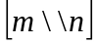 1 if m exactly divides n, otherwise 0*
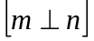 1 if m is relatively prime to n,otherwise 0*
Recurrent Problems
They’ve all been investigated repeatedly by mathematicians; and their solutions all use the idea of recuvexe, in which the solution to each problem depends on the solutions to smaller instances of the same problem.
  - THE TOWER OF HANOI
Invented by the French mathematician Edouard Lucas in 1883. The objective is to transfer the entire tower to one of the other pegs, moving only one disk at a time and never moving a larger one onto a smaller.

